

LOGBOOK

BIT4107: MOBILE APPLICATION DEVELOPMENT
NAME: ANN NJERI MAINA
LECTURER: MICHAEL NYORO
SCHOOL: COMPUTING AND INFORMATICS
DEPARTMENT: INFORMATION TECHNOLOGY
COURSE: BACHELOR OF SCIENCE IN INFORMATION TECHNOLOGY
WEEK 1: INTRODUCTION TO MOBILE DEVELOPMENT.

Android Studio
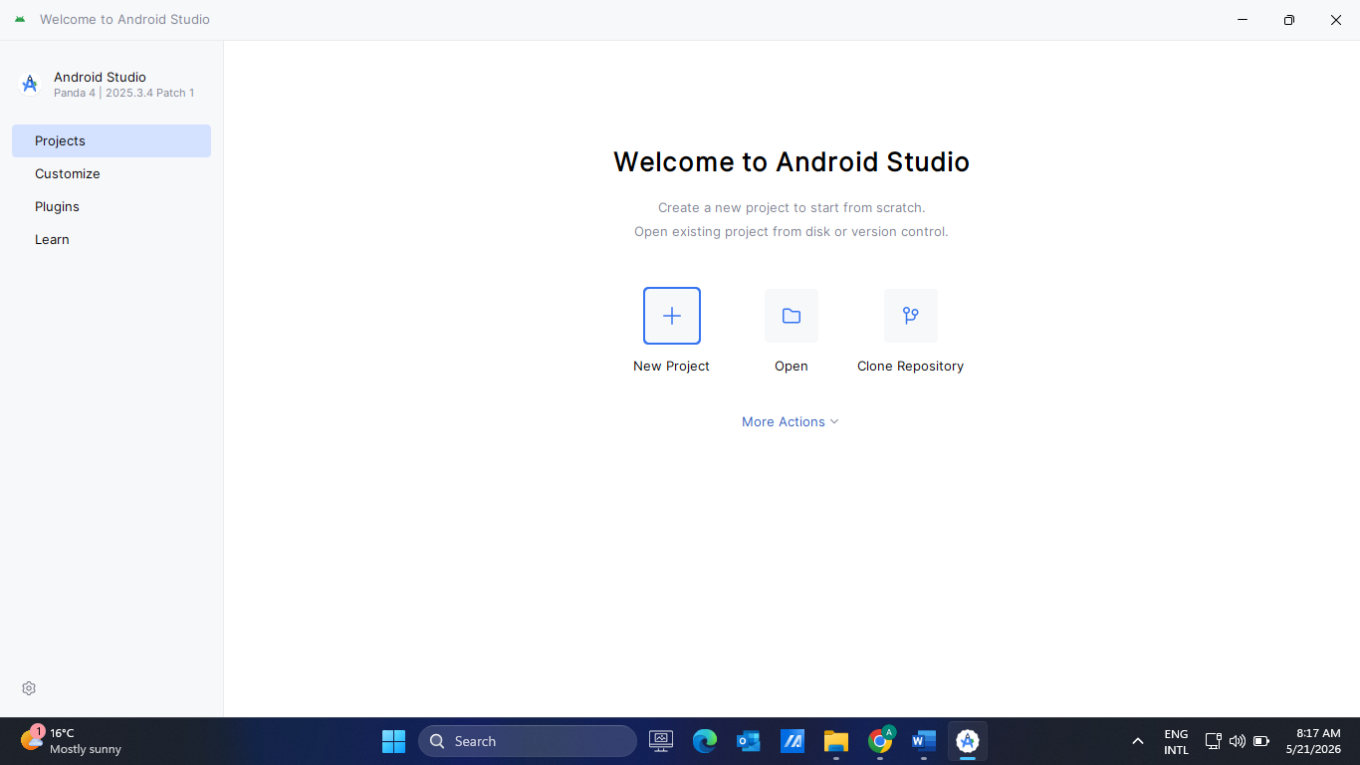

Android Studio Setup
- Install SDK Manager
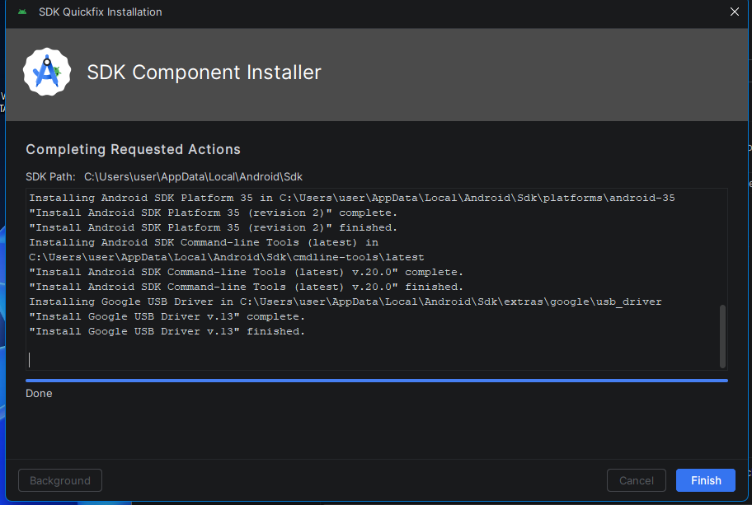

- Configure Android Emulator
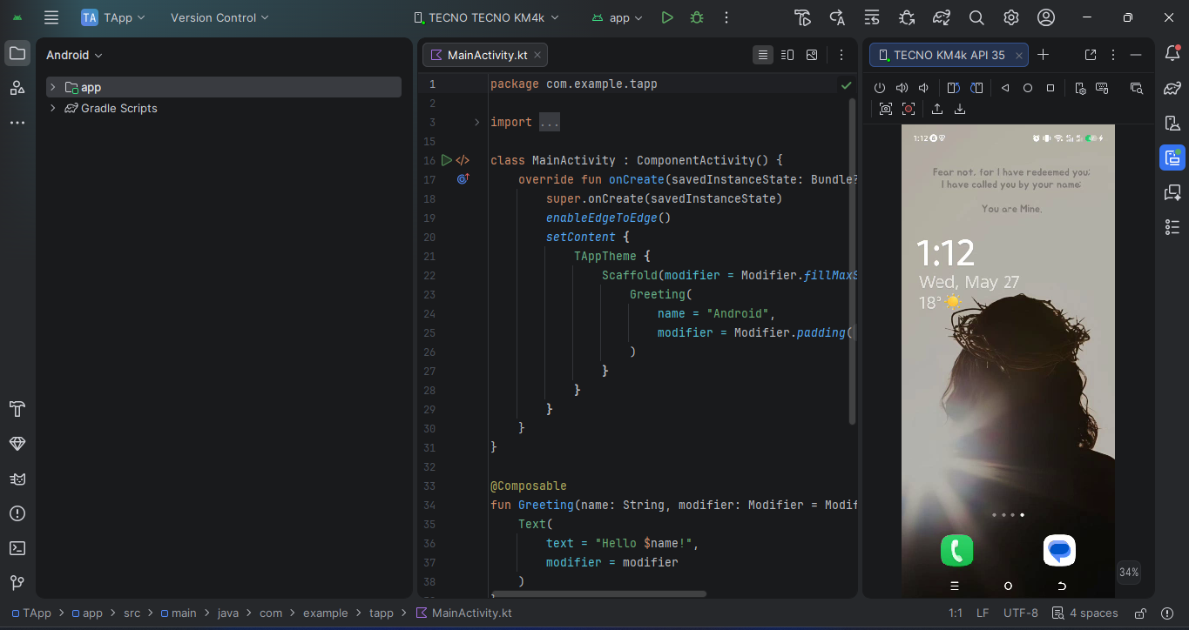
- Install Gradle.
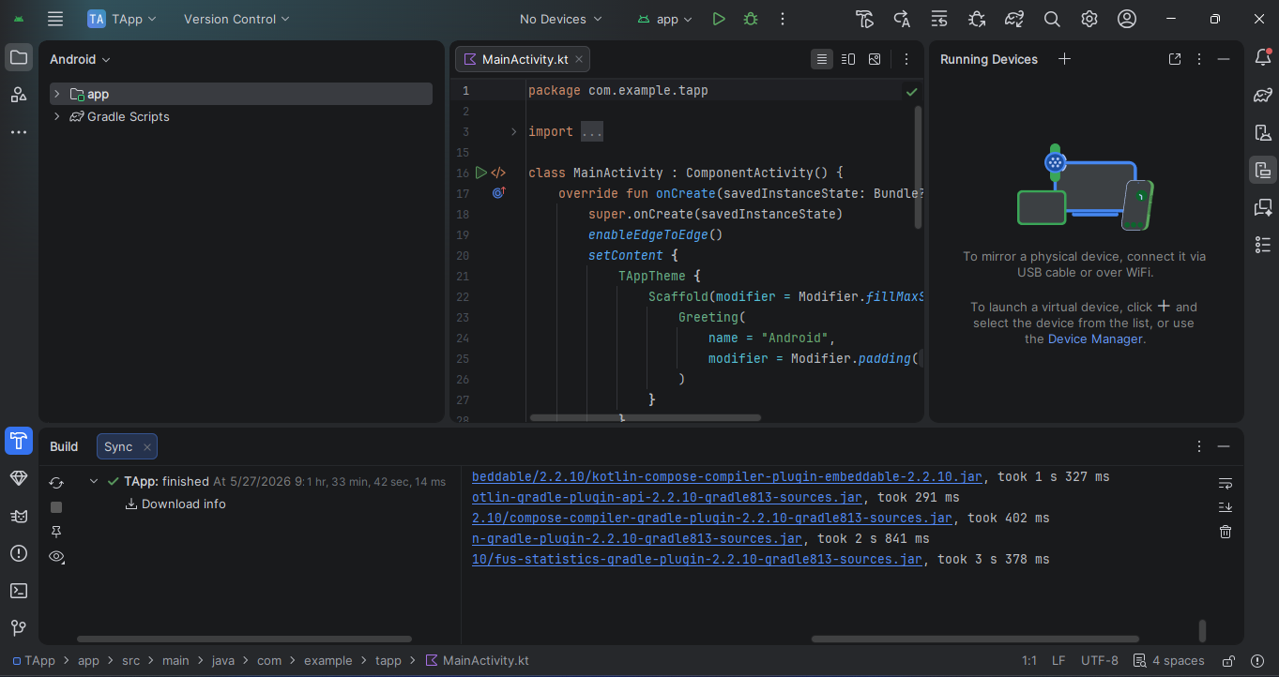

Flutter Setup
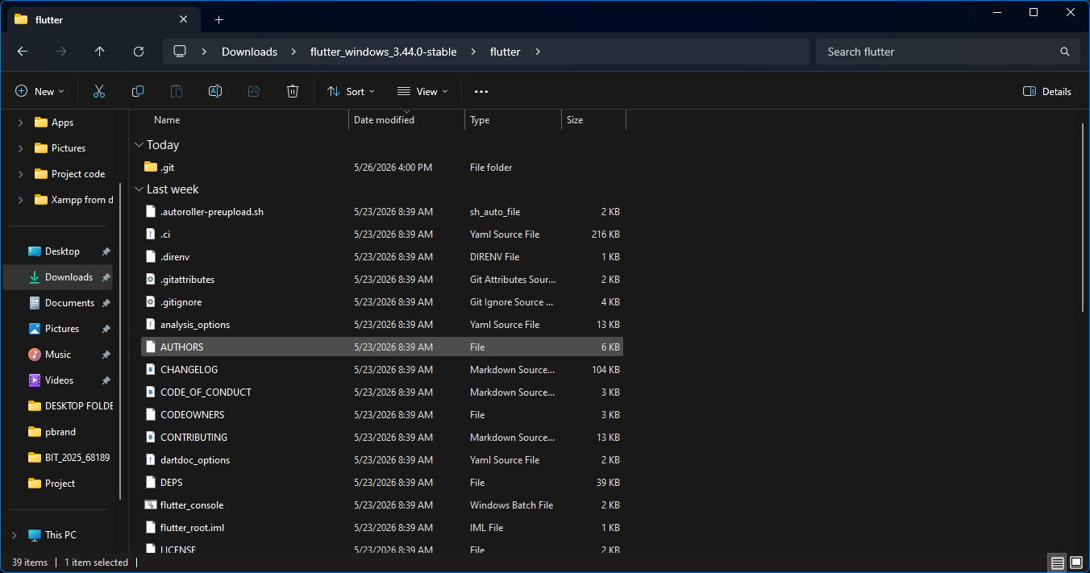
Commands:
flutter doctor
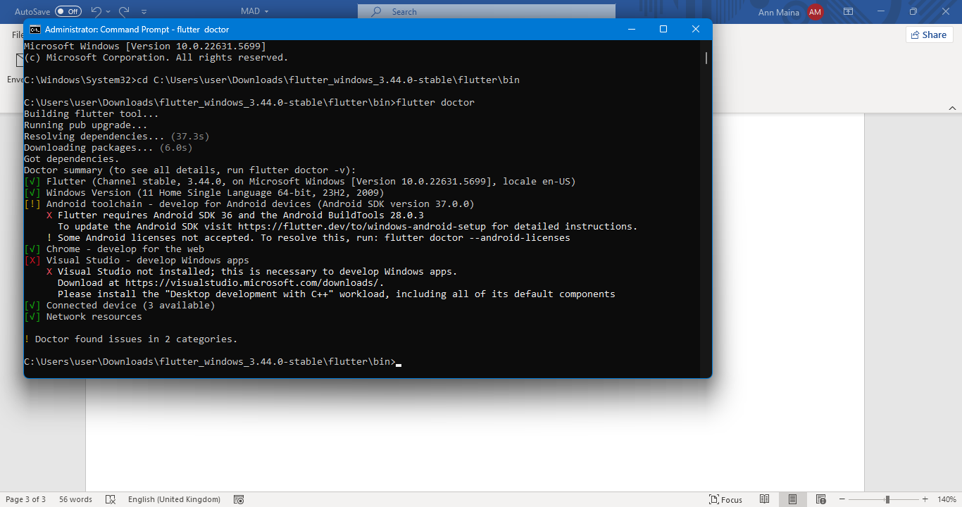
flutter create firstapp
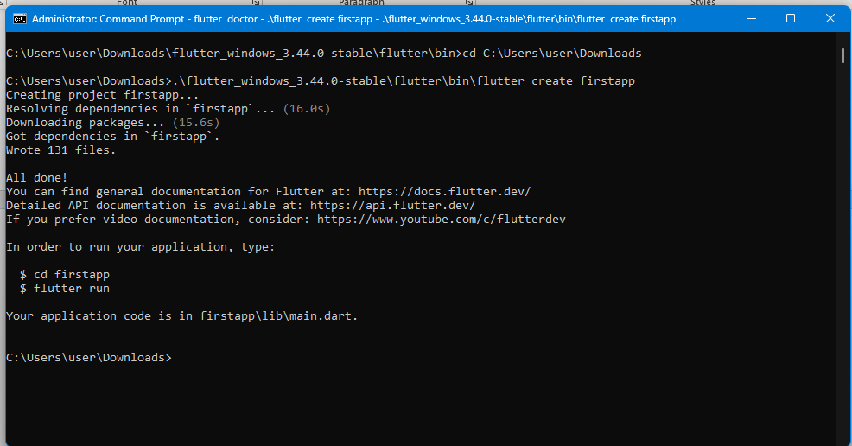

Practical Exercise
Create:
“Hello World Mobile App”
- Create project
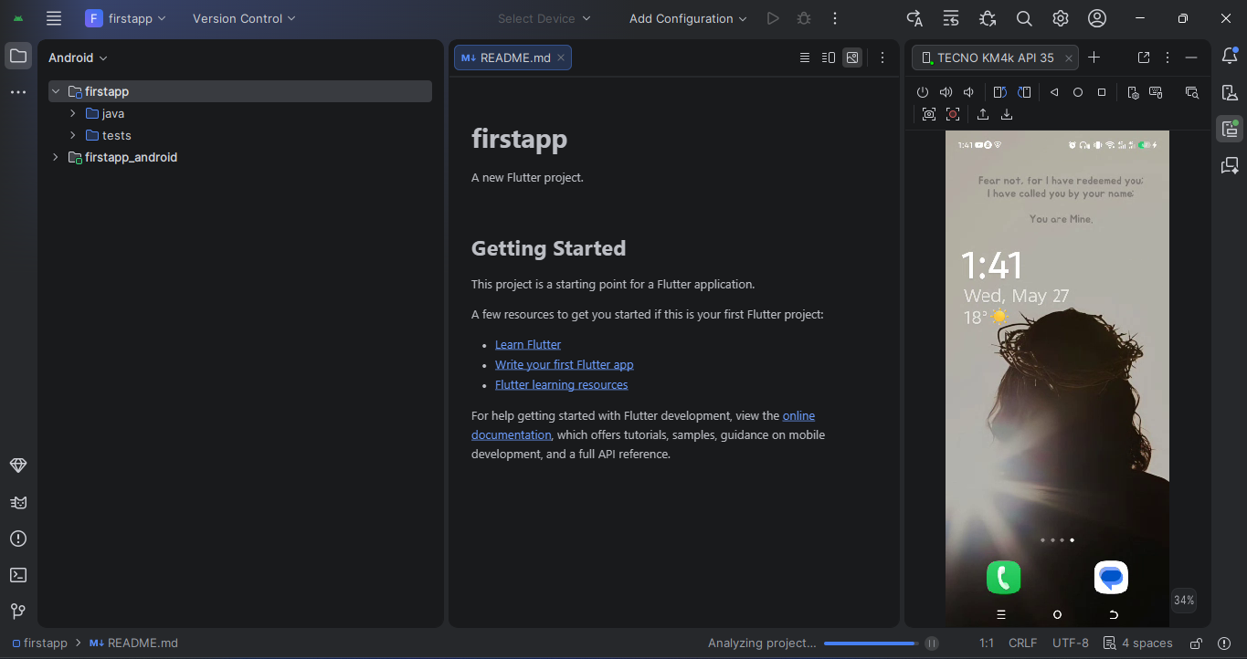
- Edit text
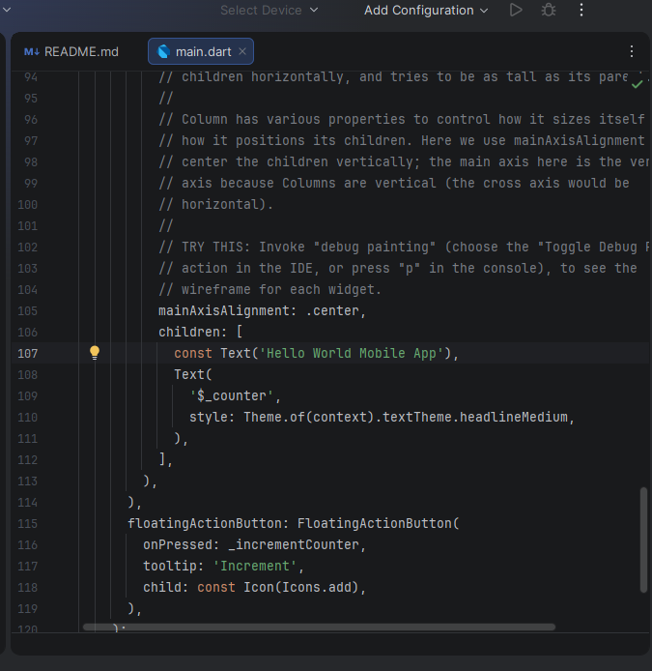

- Change colors
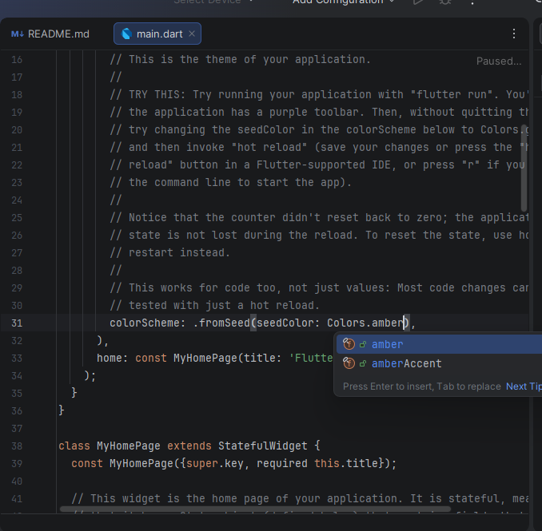
- Add button
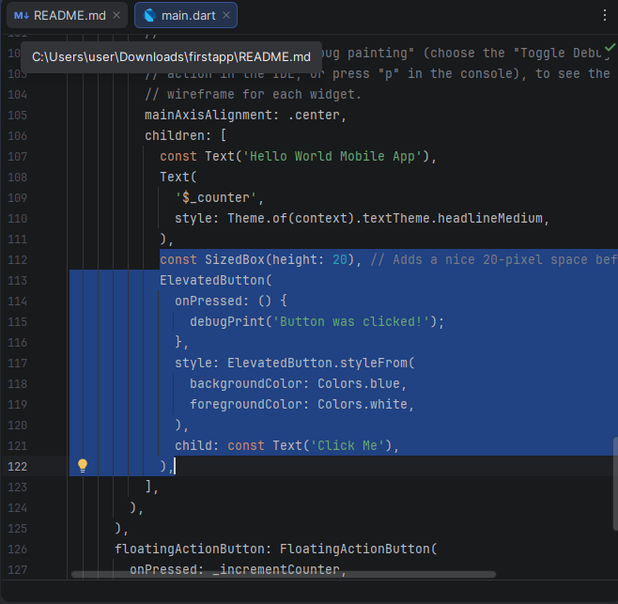
- Run on emulator
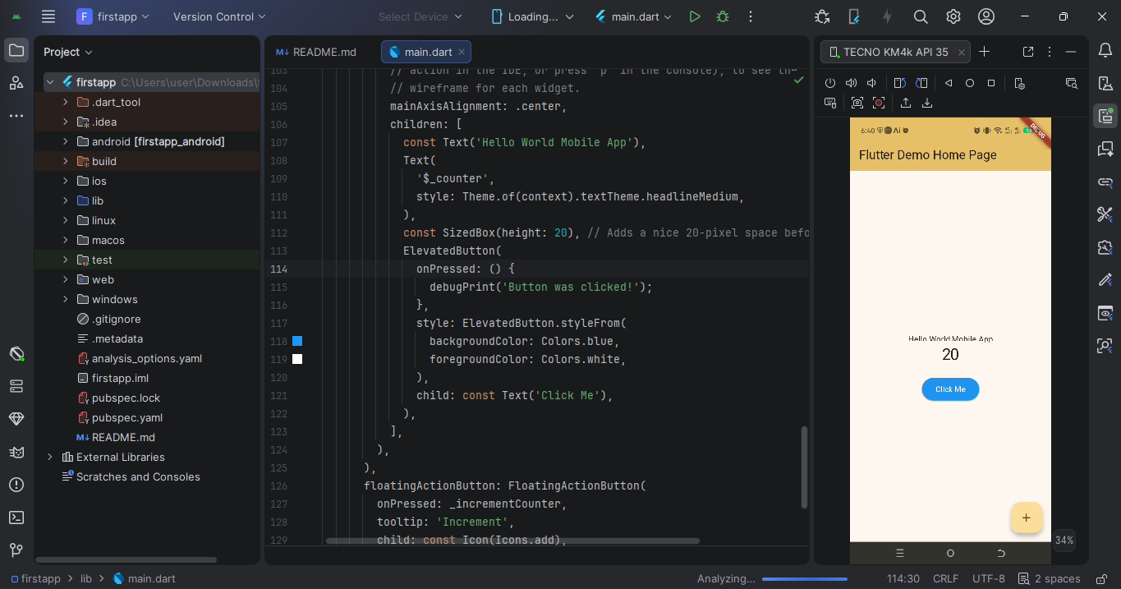

WEEK 2: PROGRAMMING LANGUAGES AND FRAMEWORKS

ASSIGNMENT
Students build:
Mini Student Management App
Features:
- Login page
- Student registration
- Save records locally
- Simple navigation

LOGIN PAGE
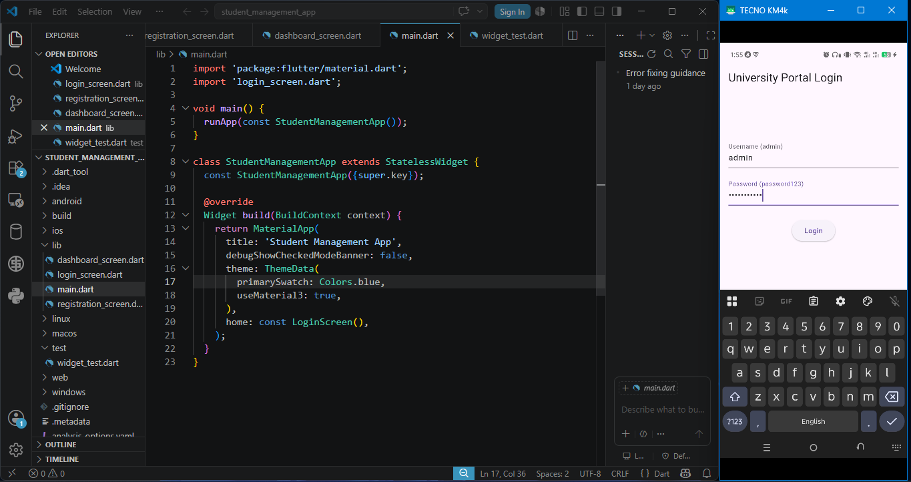

STUDENT REGISTRATION
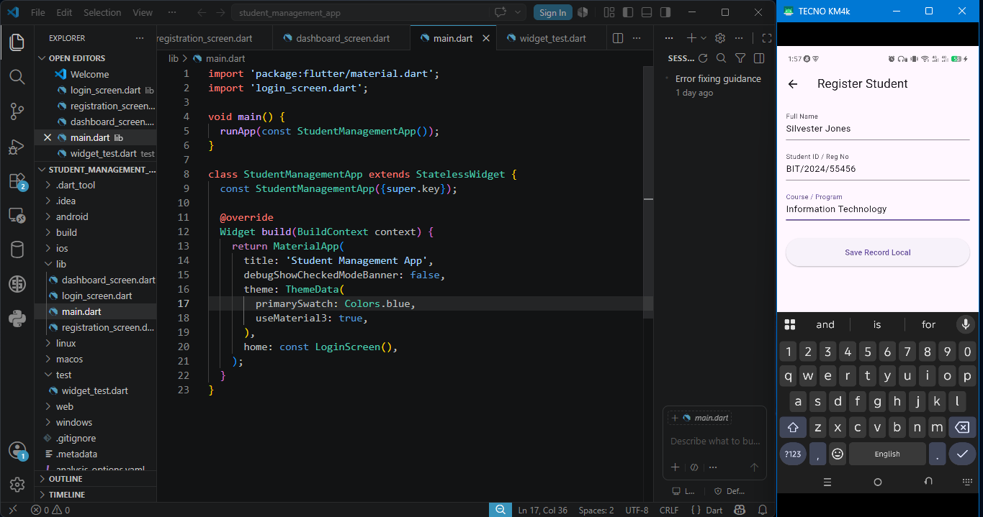

SAVE RECORDS LOCALLY and SIMPLE NAVIGATION
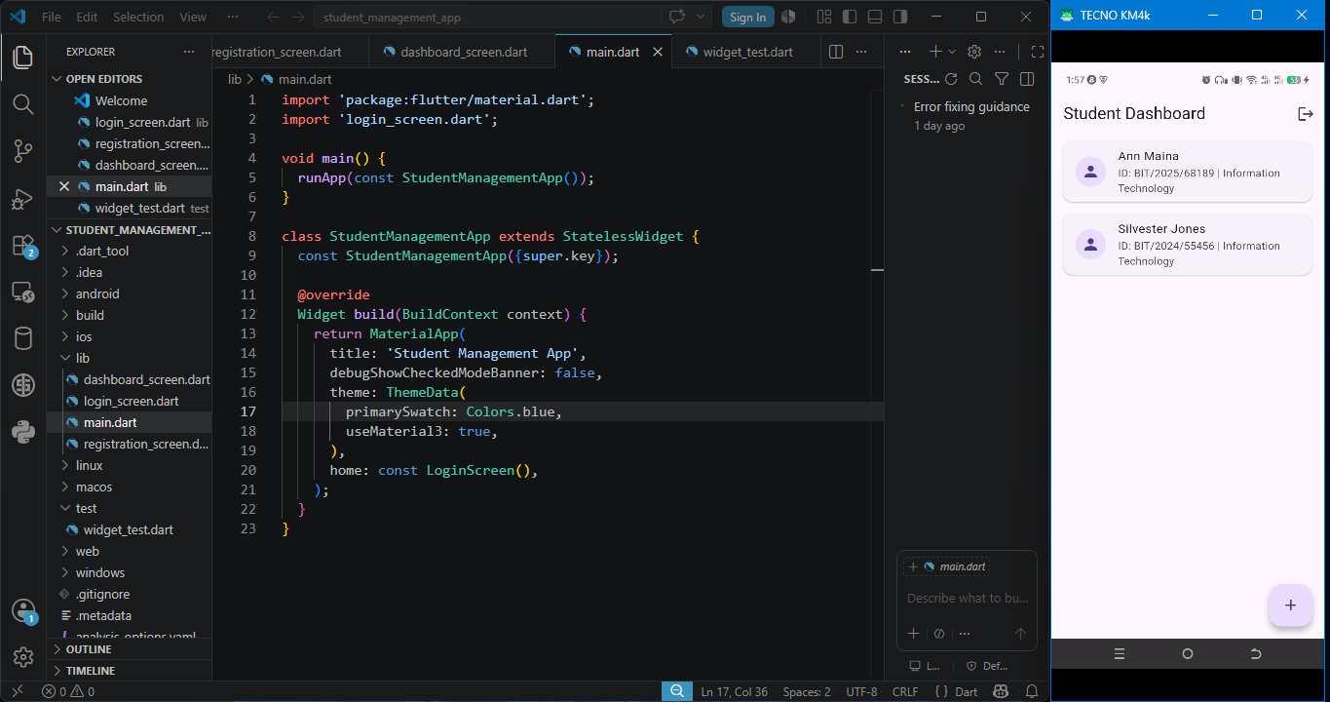

WEEK 3: USER INTERFACE (UI) DEVELOPMENT

ASSIGNMENT

Build a Complete UI Prototype
Requirements:
- 5 Screens minimum
- Navigation working
- Responsive design
- Modern UI
- Functional forms
Tools:
- Figma + Flutter or React Native

FIGMA SETUP
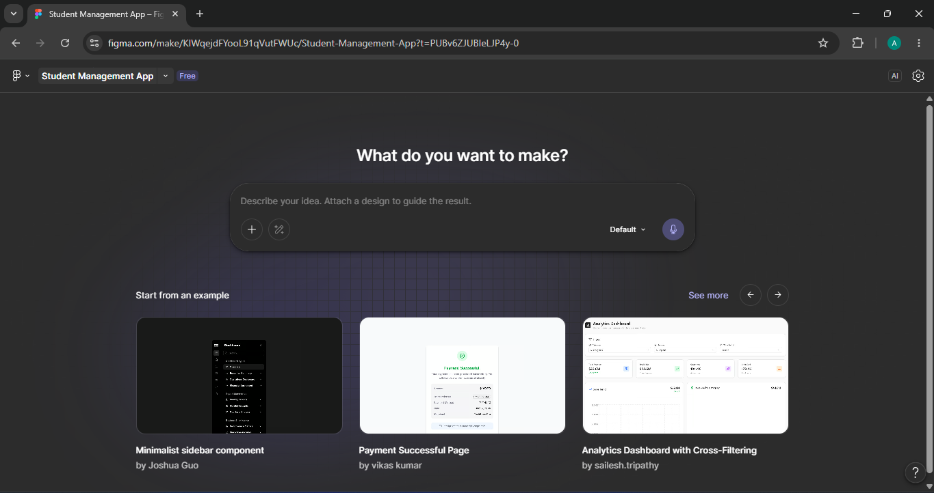
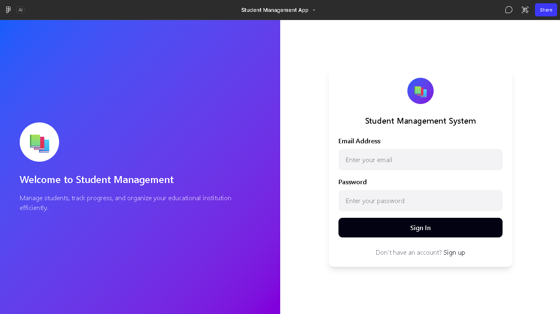

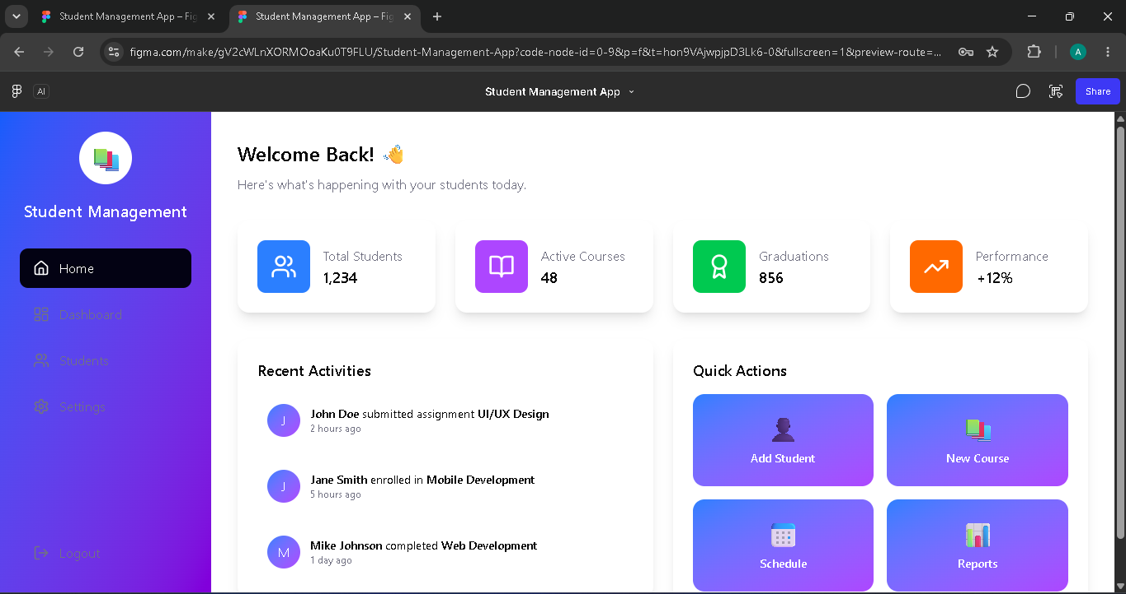
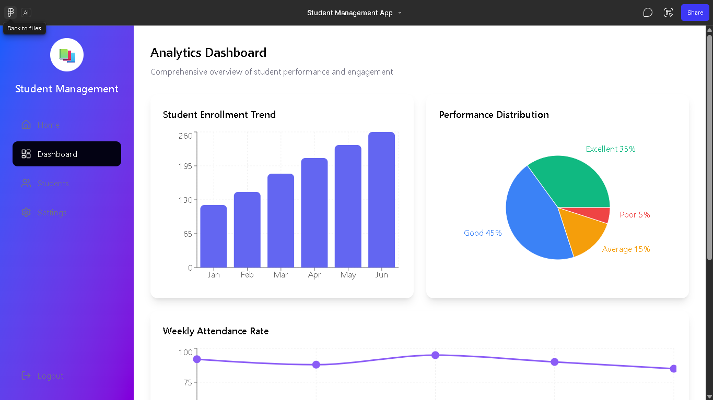
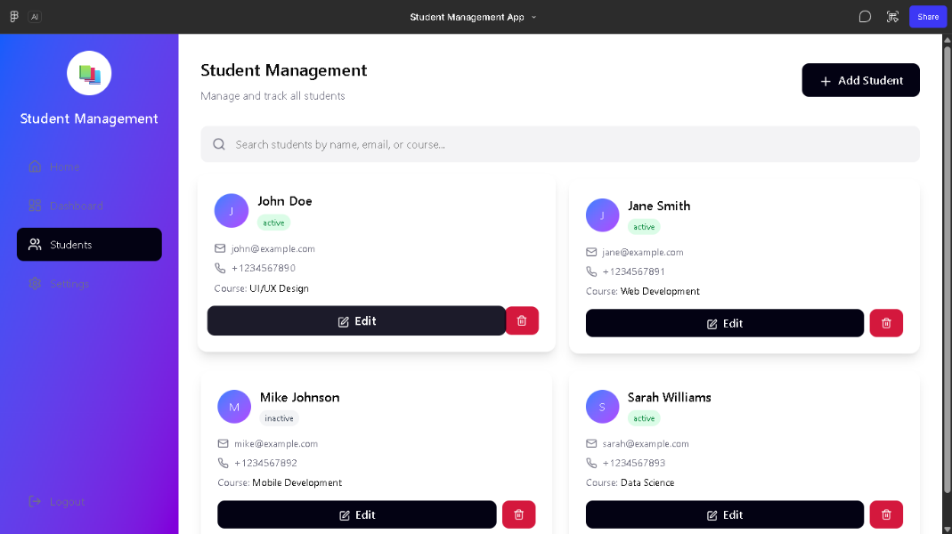
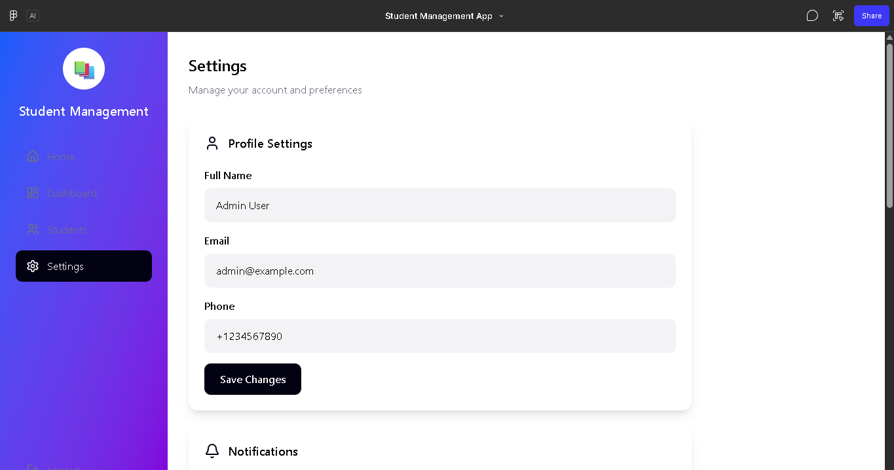

WEEK 4: DATABASE MANAGEMENT.
Screenshots
Practical Exercise And Assignment
Create a Student Registration Application that stores and displays student records.
Develop an entity Record Management App with add, update, delete and search functionality.
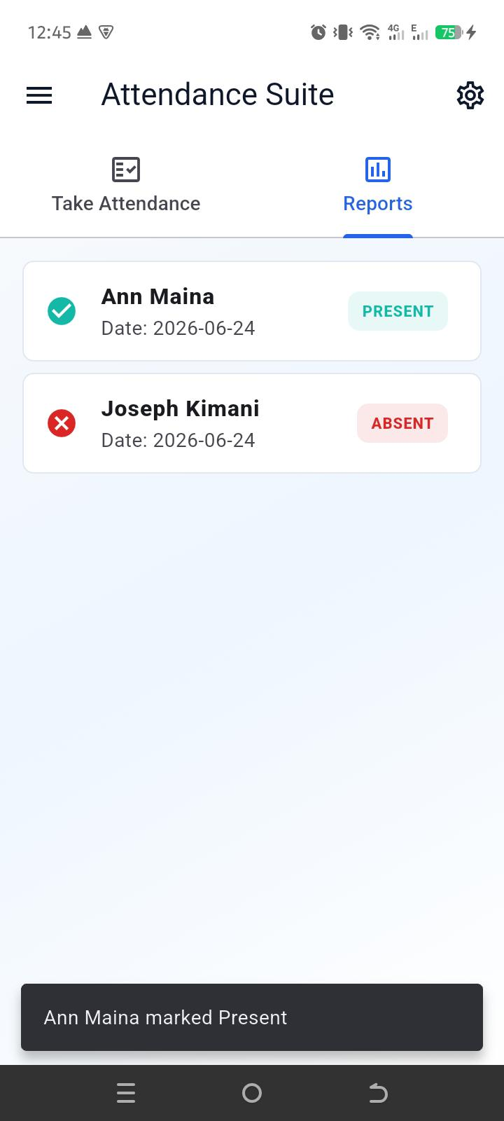
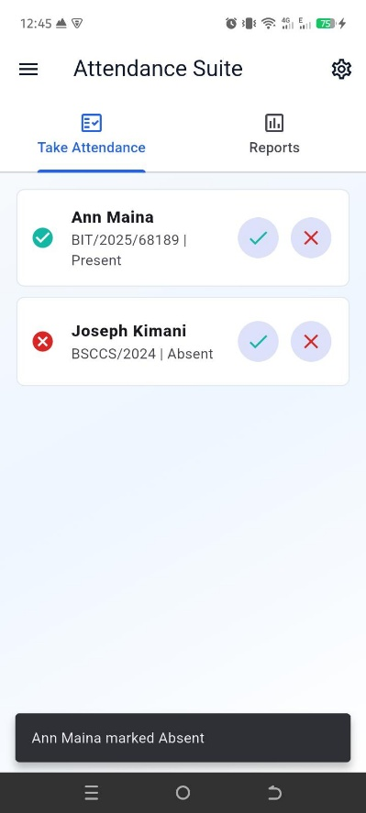

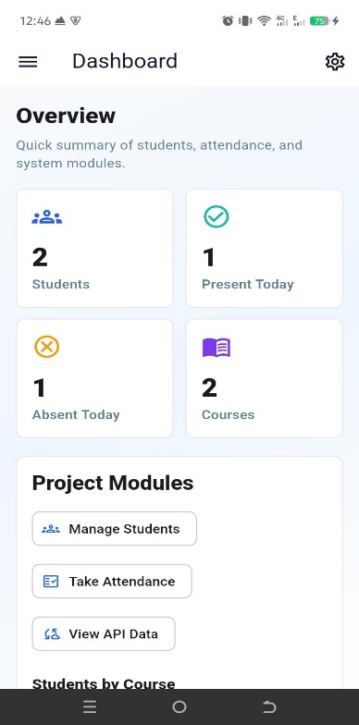

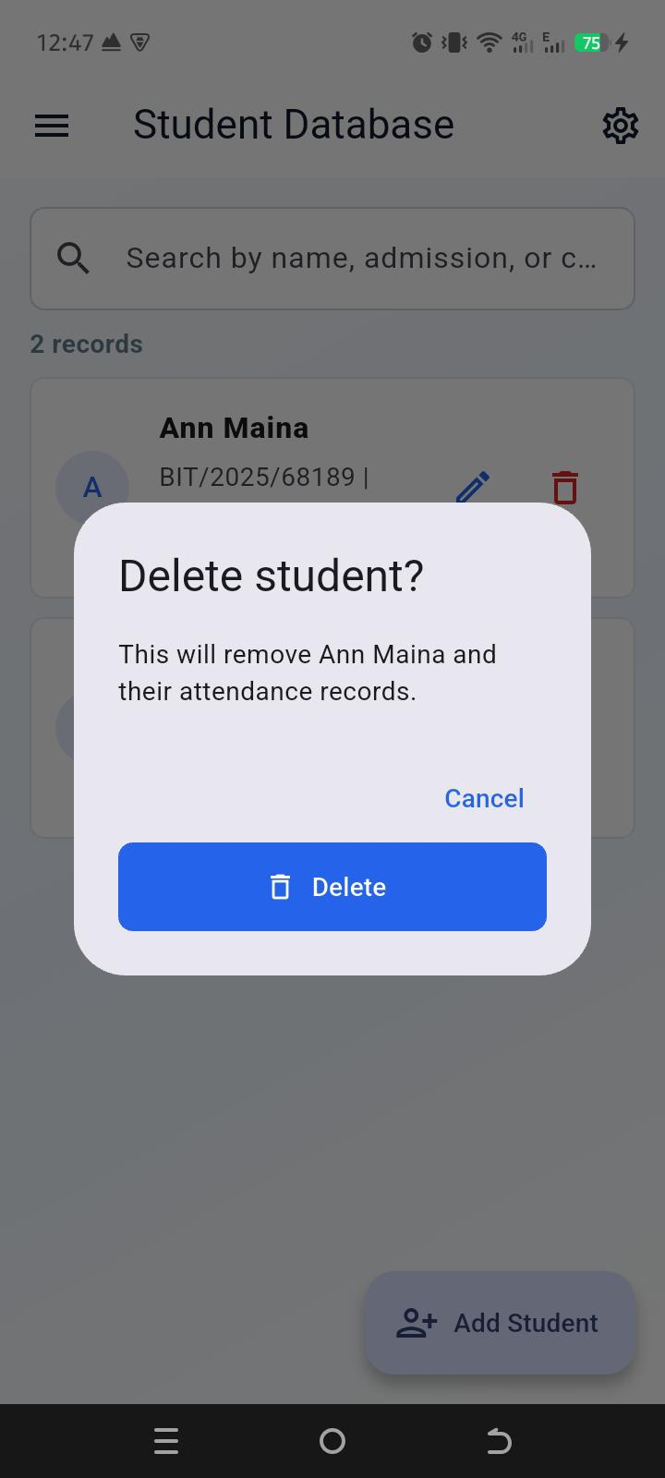
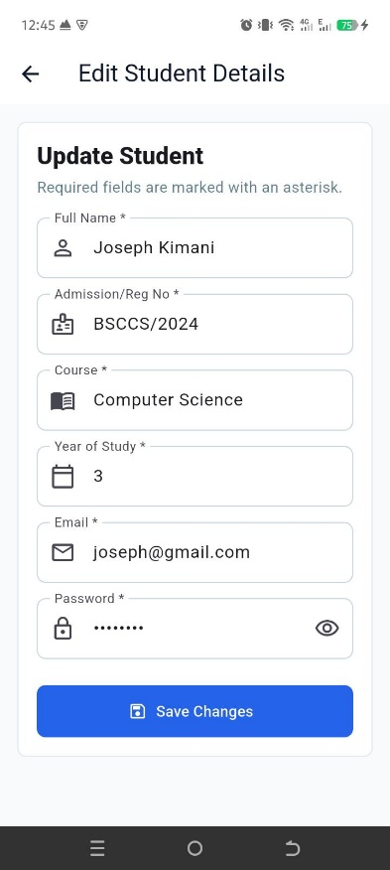

WEEK 5: NETWORKING.

Screenshots.
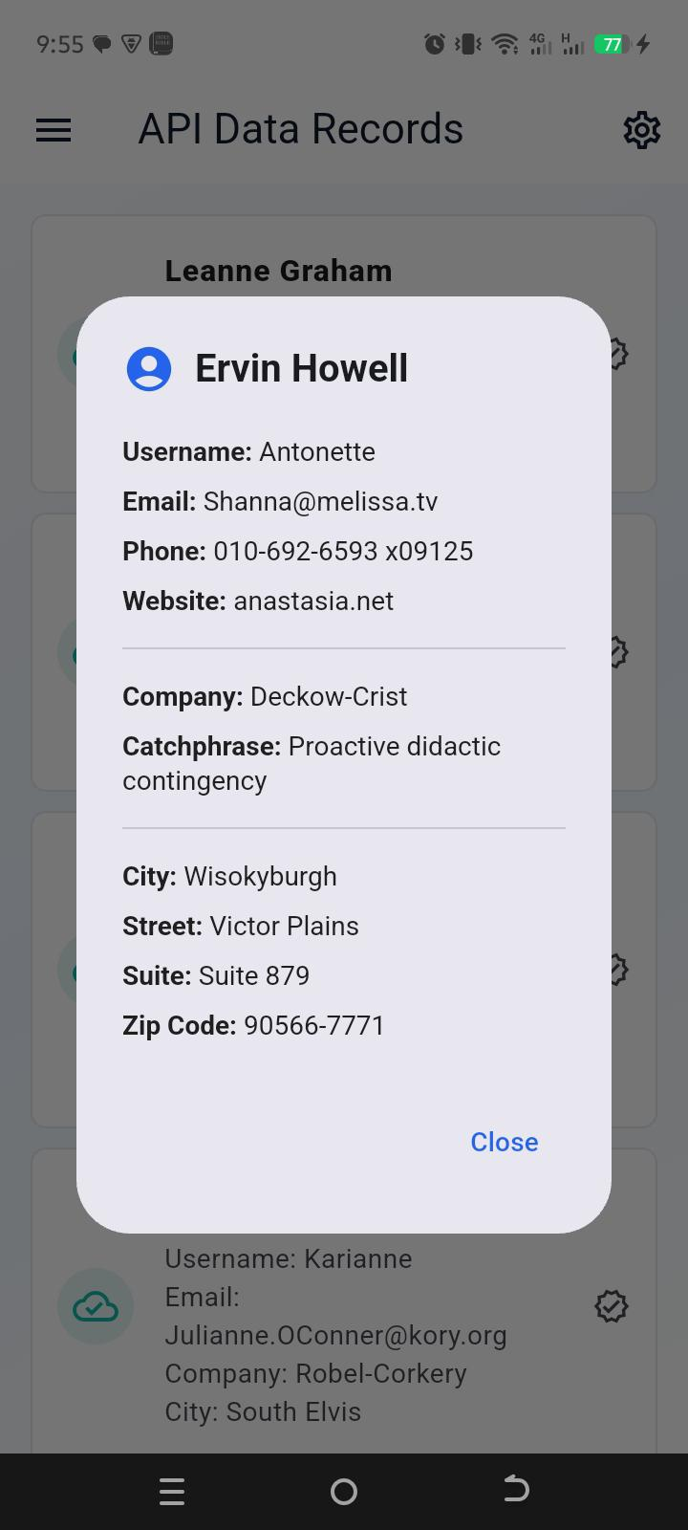
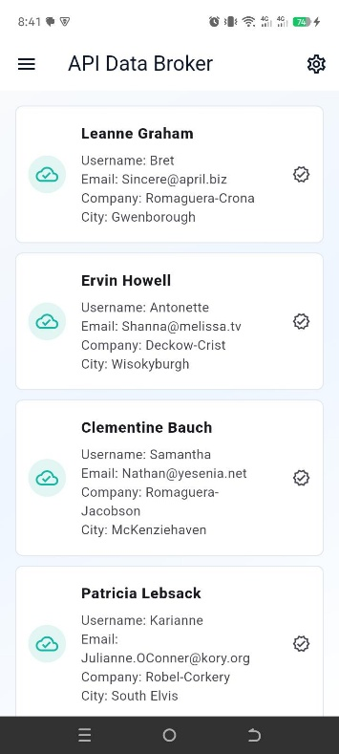

WEEK 6 AND 7: NETWORK ASPECTS AND DATA STORAGE AND DATABASE IN MOBILE APP DEVELOPMENT
SCREENSHOTS



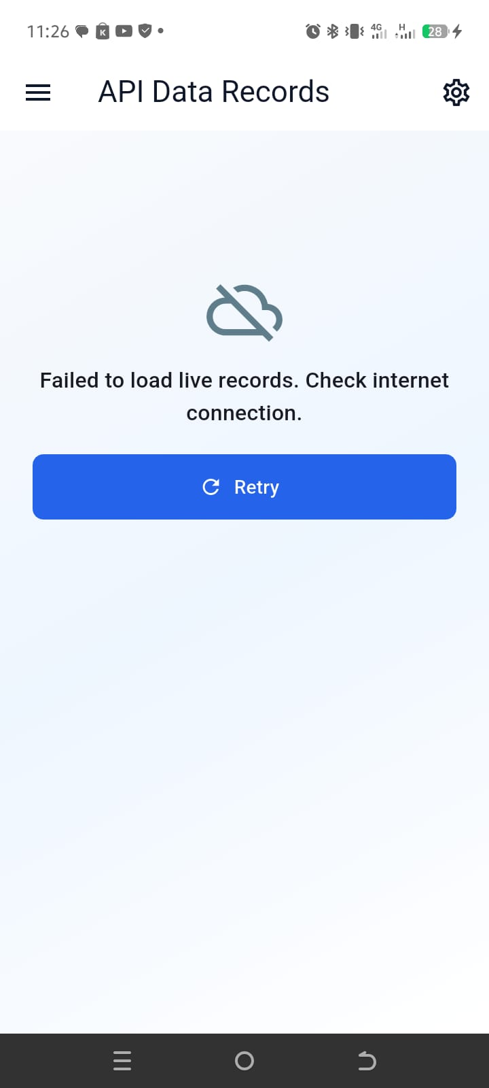

WEEK 8: EVENT HANDLING
SCREENSHOTS
Class based event handling


Keyboard input handling
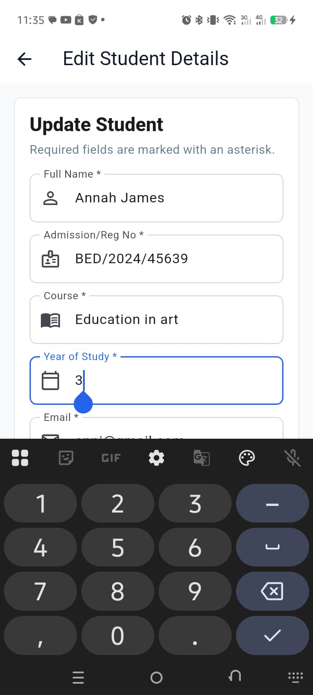

Input validation
